Nathan Gaffney

24-September-2014

CST-183-FA110-14FA-COURSE

This program will simulate games of rock, paper, and scissors while counting the wins .

Step 1. Pseudocode

Char computer, player

Int numGames, computerWIns, playerWins

Validate date for numGames

For numGames

Random computer pick

Prompt for player pick

if player != computer

palyer rock beats comp scissors. playerWins ++

player paper beats comp rock. playerWins++

player scissors beats comp paper. playerWins++

else computerWIns ++

Step 3.

/****************************************  
Created by: Nahtan Gaffney  
24-Sep-2014  
THis program will simulate rolling of dice.  
The program will also display wins/ties.  
CST-183-FA110-14FA-COURSE  
*****************************************/  
import javax.swing.JOptionPane;  
import java.util.Random;  
public class RockScissorPaper  
{  
 public static void main (String args[])  
 {  
 Random generator = new Random();  
 boolean games =false, choices= false;  
 String compChoices = "RSP";  
 String input;  
 char computerPick, playerPick ='o';//Choices  
 int numberGames=0; //# of games played  
 int computerWins=0, playerWins =0; //# of wins  
 int count=0;  
 int game = 1;  
 String playerHisto="";  
 String compHisto="";  
   
 while (games == false)  
 {  
 //Get number of games and then conver to int  
 numberGames = Integer.parseInt(JOptionPane.showInputDialog("Enter number of games to play"  
 + " between 1-8: "));  
 if (numberGames >= 1&&numberGames <=8)  
   
 {games = true;}  
 }  
 while (count<numberGames)  
 {  
 computerPick = compChoices.charAt(generator.nextInt(compChoices.length()));  
 while (choices == false)  
 {  
 input = (JOptionPane.showInputDialog(  
 "Game: "+game+  
 ": Enter choice (R,S,or P)"));  
 input = input.toUpperCase();  
 playerPick = input.charAt(0);  
 if (playerPick == 'R' //Check for valid Input  
 ||playerPick == 'S'   
 ||playerPick == 'P')  
 {choices = true;}  
 }  
 if (!(playerPick==computerPick))  
 {  
 if (playerPick=='R' && computerPick=='S')  
 { playerWins++;  
 JOptionPane.showMessageDialog(null,"Player Wins","Game: "+game,  
 JOptionPane.INFORMATION_MESSAGE);  
 }  
 else if (playerPick=='S'&&computerPick=='P')  
 { playerWins++;  
 JOptionPane.showMessageDialog(null,"Player Wins","Game: "+game,  
 JOptionPane.INFORMATION_MESSAGE);  
 }  
 else if (playerPick=='P'&&computerPick=='R')  
 { playerWins++;  
 JOptionPane.showMessageDialog(null,"Player Wins","Game: "+game,  
 JOptionPane.INFORMATION_MESSAGE);  
 }  
 else   
 { computerWins++;  
 JOptionPane.showMessageDialog(null,"Computer Wins","Game: " +game,  
 JOptionPane.INFORMATION_MESSAGE);  
 }  
 game++;  
 count++;  
 choices = false;  
 }  
 else {JOptionPane.showMessageDialog(null,"Tie","Game: " +game,1);choices=false;}  
 }  
 for (count=0;count<playerWins;count++)  
 {  
 playerHisto += "*";  
 }  
 for (count=0;count<computerWins;count++)  
 {  
 compHisto += "*";  
 }  
 System.out.println("Player wins: " +playerHisto);  
 System.out.println("Computer wins: " +compHisto);  
 }  
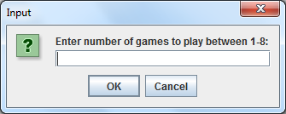

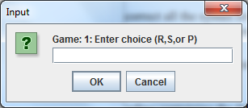

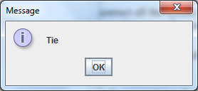

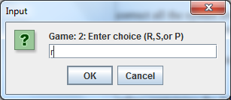

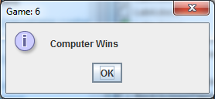

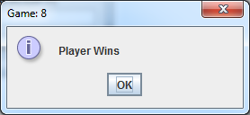

ÏÏ§Ï  
ÏÏ§ÏPlayer wins: ***  
ÏÏ§ÏComputer wins: *****  
ÏÏ§Ï